
Land Information Ontario (LIO) Warehouse
Data Class Name: Waterpower Potential Site
Documentation
Produced by: Information Access and Information Management Policy Unit
Ministry of Natural Resources and Forestry
Date: November 10, 2015

Purpose

This document provides additional information to support the use of geospatial data. The Physical Model Diagram provides a visual representation of the relationships in the data class. The Data Change History lists all the modelling and access changes that have occurred during the lifecycle of the data class.

Need Assistance?
Please contact LIO Support at lio@ontario.ca or 705-755-1878 if you require help.

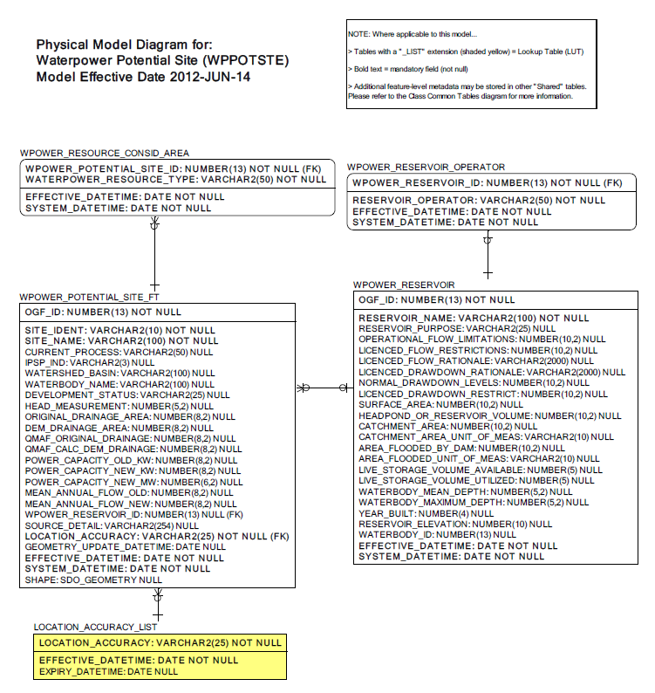

Data Class Change History

Data Class Name: Waterpower Potential Site
Data Class Short Name: WPPOTSTE
Date  YYYY-MM-DD | Details of Change
2014-05-06 | Added ‘Far North’ to the list of Valid Values for WATERPOWER_RESOURCE_TYPE in the WPOWER_RESOURCE_CONSID_AREA table
2011-03-10 | Columns added to WPOWER_POTENTIAL_SITE table  SOURCE_DETAIL: to capture notes related to the data source.  LOCATION_ACCURACY: Added foreign key attribute from the 'Location Accuracy List' lookup table.  WATERSHED_BASIN: To record the Official Secondary Watershed Name.
2011-03-10 | CONVERSION TO SIMPLE DATA CLASS:  LOCATION_ACCURACY_LIST added from common table structure to provide a location accuracy lookup selection list.
2011-03-10 | CONVERSION TO SIMPLE DATA CLASS:  Added and renamed 'Database Reference' from common table structure. All data/processes currently available with the 'Database Reference' table are to be maintained. (Two Columns have been removed: 'External Reference Type', and 'Type Other Description').
2005 | Column Change: WPOWER_POTENTIAL_SITE.MEAN_ANNUAL_FLOW_NEW Column increased from numeric(5,2) to numeric(8,2)
2005 | Column Change: WPOWER_POTENTIAL_SITE.MEAN_ANNUAL_FLOW_OLD Column increased from numeric(5,2) to numeric(8,2)
2005 | Column Added: WPOWER_POTENTIAL_SITE.INTEGRATED_POWER_SYSTEM_PLAN_INDICTORY  An indicator Column will be added to identify if a waterpower potential site has been identified in the IPSP (Integrated Power System Plan).
2003 | NEW Data Class
Data Description
Please refer to the metadata record for the data description.

